**Shri G.S. Institute of Technology and Science**

**INDORE**



**Department of Information Technology and Application**

**MCA First Year Semester I January -June 2025**

**Lab Assignment II**

**CT10708: Object Oriented Programming Using Java**

SUBMITED TO SUBMITTED BY

Ms. Sukanya Sinha SHIV ARORA

Ms. Khushi Solanki Enrolment No.

0801CA241133

Que1) 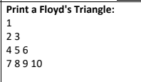

*public class* pattern_1 {  
 *public static void* main(String[] args){  
 *int* num = 1;  
 System.***out***.println("Shiv Arora");  
 *for* (*int* i = 1; i <= 4; i++) {  
 *for* (*int* j = 1; j <= i; j++) {  
 System.***out***.print(num++ + " ");  
 }  
 System.***out***.println();  
 }  
 }  
}

OUTPUT:

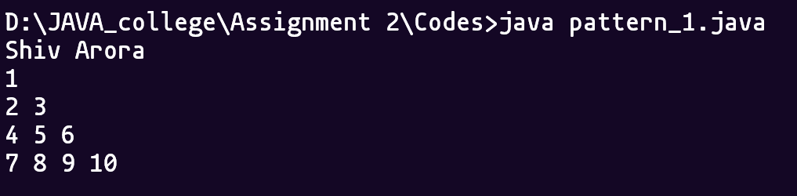

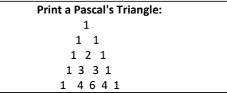

*public class* pattern_2 {  
 *public static void* main(String[] args) {  
 System.***out***.println("Shiv Arora");  
 *int* rows = 5;  
 *for* (*int* i = 0; i < rows; i++) {  
 *for* (*int* space = 0; space < rows - i - 1; space++) {  
 System.***out***.print(" ");  
 }  
 *int* num = 1;  
 *for* (*int* j = 0; j <= i; j++) {  
 System.***out***.print(num + " ");  
 num = num * (i - j) / (j + 1);  
 }  
 System.***out***.println();  
 }  
 }  
}

OUTPUT:

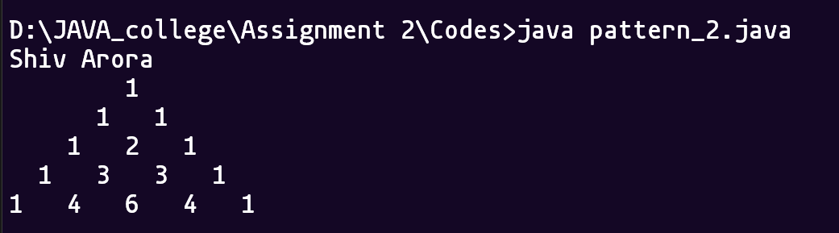

Que2) 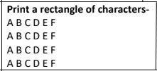

*public class pattern_3 {  
 public static void main(String[] args) {  
 System.****out****.println("Shiv Arora");  
 for (int i = 0; i < 4; i++) {  
 for (char ch = 'A'; ch <= 'F'; ch++) {  
 System.****out****.print(ch + " ");  
 }  
 System.****out****.println();  
 }  
 }  
}*

OUTPUT:

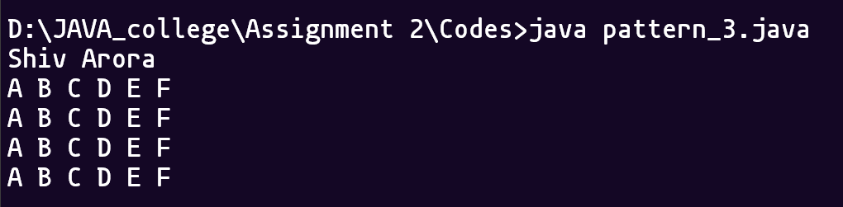

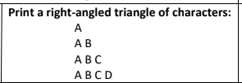

*public class* pattern_4 {  
 *public static void* main(String[] args) {  
 System.***out***.println("Shiv Arora");  
 *for* (*int* i = 1; i <= 4; i++) {  
 *for* (*char* ch = 'A'; ch < 'A' + i; ch++) {  
 System.***out***.print(ch + " ");  
 }  
 System.***out***.println();  
 }  
 }  
}

OUTPUT:

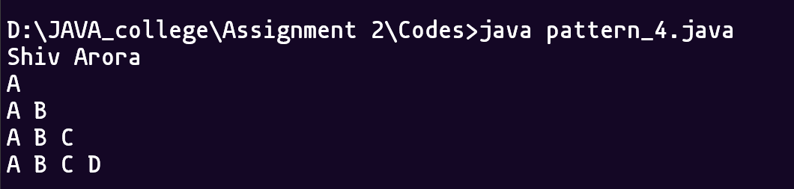

Que 3) 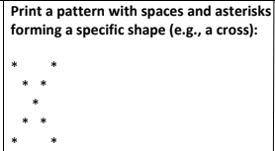

*public class* pattern_5 {  
 *public static void* main(String[] args) {  
 System.***out***.println("Shiv Arora");  
 *int* size = 5;  
 *for* (*int* i = 0; i < size; i++) {  
 *for* (*int* j = 0; j < size; j++) {  
 *if* (i == j || i + j == size - 1)  
 System.***out***.print("* ");  
 *else* System.***out***.print(" ");  
 }  
 System.***out***.println();  
 }  
 }  
}

OUTPUT:

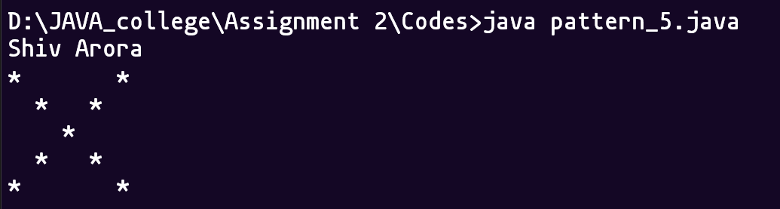

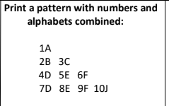

*public class* pattern_6 {  
 *public static void* main(String[] args) {  
 System.***out***.println("Shiv Arora");  
 *int* num = 1;  
 *char* ch = 'A';  
 *for* (*int* i = 1; i <= 4; i++) {  
 *for* (*int* j = 0; j < i; j++) {  
 System.***out***.print(num++ + "" + ch++ + " ");  
 }  
 System.***out***.println();  
 }  
 }  
}

OUTPUT:

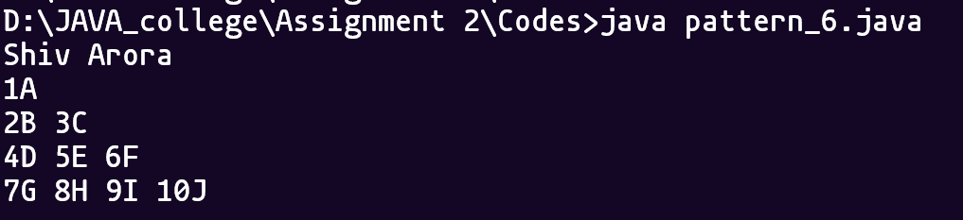

Que 4) 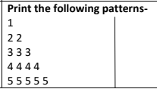

*public class* pattern_7 {  
 *public static void* main(String[] args) {  
 System.***out***.println("Shiv Arora");  
 *for* (*int* i = 1; i <= 5; i++) {  
 *for* (*int* j = 0; j < i; j++) {  
 System.***out***.print(i + " ");  
 }  
 System.***out***.println();  
 }  
 }  
}

OUTPUT:

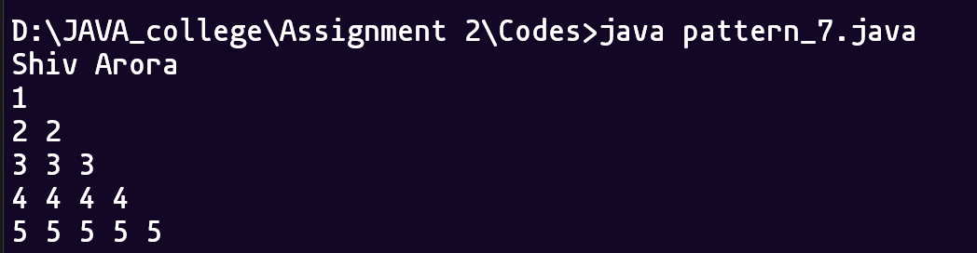

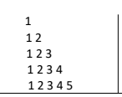

*public class* pattern_8 {  
 *public static void* main(String[] args) {  
 System.***out***.println("Shiv Arora");  
 *for* (*int* i = 1; i <= 5; i++) {  
 *for* (*int* j = 1; j <= i; j++) {  
 System.***out***.print(j + " ");  
 }  
 System.***out***.println();  
 }  
 }  
}

OUTPUT:

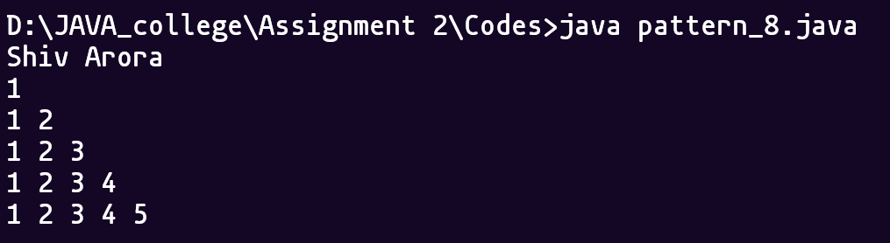

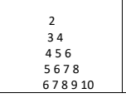

public class pattern_9 {

public static void main(String[] args) {

System.out.println("Shiv Arora");

for (int i = 1; i <= 5; i++) {

int num = i + 1;

for (int j = 0; j < i; j++) {

System.out.print(num++ + " ");

}

System.out.println();

}

}

}

OUTPUT:

